Sample Paper in Econometrics
This is a sample research paper for an introductory course in econometrics. It shows how to communicate econometric work in written form. The paper integrates many writing instructions and rules into a single example and shows how they all fit together. You should pay attention to the structure of the paper: how it is divided into sections and how each section serves a distinct purpose. You should also note how the descriptive statistics and empirical results are presented.
The paper includes numerous notes in the margins. These notes explain the purpose of each paragraph, and provide comments on tables and other aspects of the paper. The margin notes are there to make you aware of the writing process. They are designed to help you bridge the gap between reading and understanding on one hand, and writing and creating knowledge on the other. The readings which have been assigned in your economics courses are finished products which you are able to read and understand. However, in order for you to be able to create a finished product yourself, you need to become aware of how such a product is created. The notes in the margins reveal the thinking and consideration that go into each section, paragraph and table, and should therefore help you in writing your own paper.
It is worth emphasizing that you should use this paper only as a guide. You should not copy the paper and simply fill in your own names, words and numbers. You can deviate from the order and purpose of each paragraph in order to meet the needs of your own work. You can add separate sections on prior literature, methodology or theory. Such sections would normally come after the introduction. The sample paper includes the discussion of prior literature in the introduction. The theory and methodology are folded into the Introduction, Data and Empirical Results sections. The absence of a separate theory or methodology sections is not uncommon in applied empirical papers. However, theory or methodology sections are a must when the empirical question is derived from an explicit theoretical model or when the methodology requires a longer explanation. You are also welcome to include additional tables or graphs. What should remain the same, though, is that each section, paragraph, table and graph has a purpose, and that they are organized in a logical manner.
For printer friendly version click here.

Concepts illustrated in the paper
(The list is expandable. Click on the concept to see its description.)
Structure:  - Introduction (see example)  - The Introduction should convey four things. First, what is the question that the paper asks. Second, why is the question important. Third, how is the paper going to answer the question. Finally, how is the paper related to existing work. The introduction is the most important part of any paper. No one will continue to read any further if the introduction is confusing or poorly written.  - Data (see example)  - The Data section should accomplish three things: First, state the sources of data. Second, discuss the variables used and how they relate to the concepts that they are supposed to measure. Finally, present the data’s descriptive statistics.  - Empirical Results (see example)  - The Empirical Results section should present and discuss the empirical results. The presentation of results is usually done with a table. The discussion of results typically includes a statement of whether the results support or refute the hypothesis, a statement of whether the results are statistically significant, interpretation of the magnitude of the coefficients and a comment on functional form.  - Conclusion (see example)  - The conclusion should accomplish three things: summarize the results, explore the implications of the results, and point to future research. | Writing Style:  - Citation Style (see example)  - The citation and bibliography styles most commonly used in economics are detailed in the Chicago Manual of Style.  - Use of acronyms (see example)  - The first time an acronym is used it should be written out, followed by the acronym in parenthesis.  - Use of first person (see example)  - It is acceptable to use first person (I) in an economics paper.  - Coherence (see example)  - Make each sentence linked to the previous one.  - Tense (see example)  - It is appropriate to use past tense when describing the construction of your variables. However, use present tense when referring to tables or your results.
Conventions in an Empirical Paper:  - Descriptive Statistics Table (see example)  - A descriptive statistics table should include the list of variables and the mean, median, standard deviation, minimum and maximum. In cases where the number of observations varies from variable to variable, a column specifying the number of observations is necessary. The orientation of the table should be such that the variables are in rows and the statistics in columns. This way, even if a large number of variables are used, the table will fit on one page.  - Discussing Descriptive Statistics (see example)  - Discussing the minimum and maximum and the corresponding data points makes the data “come alive.” It also reassures the reader that the data was put together correctly.  - Rounding numbers in the text (see example)  - When discussing quantities in the text, use round numbers.  - Presentation of regression results (see example)  - Regression results are typically presented in this compact form. The columns show results from 6 different regressions. The rows show the intercept, independent variables and the R-squared. The estimated coefficients and their associated standard errors in parentheses appear inside the table. Some authors prefer to show each coefficient’s t-statistics in parentheses; therefore it is always necessary to specify this in the table’s footnote. If the independent variable is not included in a specification, the cell corresponding to that independent variable and specification is left blank. If the number of observations varies across specifications, it can be included as the last row. The asterisks are for easy identification of the significance level - the more asterisks, the higher the significance.  - Converting variables to convenient units (see example)  - In order to be able to present regression results in a compact and readable form, it is necessary to convert the variables to appropriate units. For example, the appropriate units for payroll are millions of dollars. This is because if payroll were in dollars, the coefficient in specification (3) would appear as 0.0000001 which is more difficult to fit in a table and more difficult to read.  - Interpreting estimated coefficients (see example)  - It is very important to include the units of both the independent and the dependent variables.  - Assessing economic significance (see example)  - Assessing economic significance requires judgment. Unlike statistical significance, there is no "official" benchmark for assessing economic significance. | Other:  - Title (see example)  - The title should concisely express what the paper is about. It can also be used to capture the reader's attention.  - Searching for existing literature (see example)  - EconLit is the most commonly used database for searching published papers in Economics. Working papers can be found via IDEAS, SSRN, NBERor even google.  - Effect vs. affect (see example)  - "Effect" is usually a noun (that is, it could be preceeded by "the"). "Affect" is usually a verb.  - Appeal to authority (see example)  - It is appropriate to cite other studies when justifying the use of a variable or technique. This also makes the comparison to other work easier.  - Acknowledge shortcomings of data (see example)  - It is appropriate to acknowledge the shortcomings of your data. The shortcomings could come from unreliability of the source, lack of observations or, as in this case, lack of time to properly adjust the data for inflation.

 | Does pay inequality within a team affect performance?  Tomas Dvorak* | 
 | 1. Introduction  The business of sports draws considerable attention from the media and the general public. Fans and sports writers frequently speculate about the effects of money on athletic performance. There is general agreement that more financial resources usually lead to better athletic performance. In team sports, higher pay can be used to lure better players from other teams and therefore improve performance. However, performance can also be affected by pay inequality among players within a team. On the one hand, pay inequality could have a negative effect because it may hinder cooperation among team members. In many sports, team cooperation is critical for good performance. If pay inequality creates tensions or animosity among team members, performance is likely to suffer. On the other hand, inequality could have a positive effect on performance by providing incentives. The prospect of a very large salary could be a powerful drive behind an athlete’s performance. Pay inequality might also enhance performance if low paid players learn from high paid players. This would happen when pay inequality is associated with skill inequality. For example, if a highly paid superstar can teach other players, the overall performance of a team may improve. Given that arguments can be made both ways, it is not surprising that there is little agreement on the effects of pay inequality on team performance. The purpose of this paper is to determine whether, on balance, the effect of pay inequality on performance is positive or negative. |   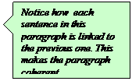
 | Understanding the effect of pay inequality on a team’s performance is important for at least two reasons. First, team managers can use this information to make decisions about which players to hire. For example, should they hire one expensive superstar and two inexpensive players, or three medium-priced players? If we find that pay inequality leads to poor team performance, then the team may perform better with three medium-priced players than one superstar and two low-priced players. Second, because salaries are a large part of contract negotiations between player associations and team owners, understanding the effects of pay inequality on performance can help determine optimal policies. For example, if pay inequality has a negative effect on performance, an argument for a higher minimum salary could be made. | 
 | There are a number of studies that look at the effects of pay inequality on performance. DeBrock, Hendricks and Koenker (2004) study the effects of pay inequality on performance in Major League Baseball (MLB) . They find that pay inequality is associated with poor performance. Frick, Prinze and Winklemann (2003) look at the effects of pay inequality in all four major leagues in North America. They find that inequality improves team performance in basketball and worsens team performance in baseball. They find no statistically significant effect of inequality on performance in football and hockey. | 
  ; | This paper looks at the effects of inequality on performance in MLB. It differs from that of DeBrock, Hendricks and Koenker (2004) in that it uses the most recent data. While the previous authors use data from 1985 through 1998, I use data from the latest two seasons: 2003 and 2004. Another difference is that I use a different measure of pay inequality. Rather than the Herfindahl index, I use the percentage of payroll earned by the best paid 20% of players. I chose the share earned by the top 20% players for two reasons: it is somewhat easier to calculate, and its magnitude is easier to interpret. | 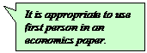
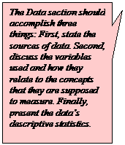  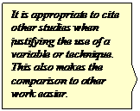 | 2. Data  The data on pay inequality was constructed in the following way. From the USA Today salary database, I collected annual salaries for each player in all MLB teams during the 2003 and 2004 seasons. I summed the salaries of all players for each team and each season to obtain the total payroll. The active roster in baseball is 25, but the database includes salaries of disabled players as well. Therefore, the number of players for each team ranges from 25 to 31. As the measure of pay inequality, I calculated the percentage of payroll earned by the highest paid 20% of players. For example, for a 30 player team I summed the salaries of the highest paid 6 players and divide that amount by total payroll. If every player earned the same amount, the best paid 20% would earn exactly 20% of the payroll. When pay is unequal, this measure is higher than 20%. The higher the share of payroll earned by the top 20% of players, the higher the pay inequality.  To measure performance I use the percentage of games won in the regular season. This data comes from BaseballReference.com. It does not include performance during league championships or the World Series. However, with 162 games per regular season, the winning percentage can be regarded as a reasonable measure of performance. This is also the measure used by DeBrock, Hendricks and Koenker (2004). | 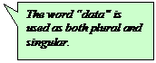  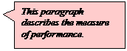
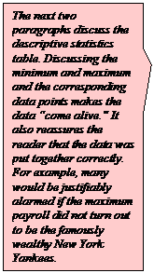  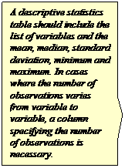 | In addition to pay inequality and performance, I use data on the total payroll of each team. This is a measure of financial resources which could be an important determinant of performance. I measure payroll in current dollars and do not adjust for inflation. While 2003 dollars are not exactly comparable to 2004 dollars, 2003 inflation was low enough not to influence the results significantly.  Table 1 shows the descriptive statistics of each variable. In the first row we see that on average the highest paid 20% of players earn about 61% of the total payroll. This implies that on a 30 player team, the six best paid players earn more than the remaining 24 combined. According to this measure, the team with the most equitable pay is the New York Yankees during the 2003 season when the top 20% of players earned only 42% of total payroll. The team with the highest inequality was the Colorado Rockies during the 2004 season. On that team, five players earned more than 78% of the team’s total payroll.  The second row in Table 1 shows that the average winning percentage is 50% which has to be the case since for every game won there is a game lost. The Detroit Tigers have the lowest winning percentage in the data with only 26% of games won during the 2003 season. The maximum winning percentage in the data is for the St. Louis Cardinals, who won nearly 65% of their games during the 2004 season. Finally, the last row in Table 1 shows that the average payroll is about 70 million dollars. The range of payroll is quite striking. It goes from less than 20 million dollars for the Tampa Bay Rays to over 184 million for the New York Yankees.  Table 1: Descriptive Statistics  mean median st.dev. min max  Top20share (in %) 61.0 61.4 8.0 42.2 78.3  Games Won (in %) 50.0 51.6 8.2 26.5 64.8  Payroll (in mil. USD) 70.0 65.3 30.3 19.6 184.2 | 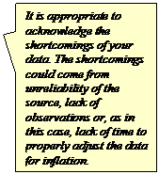  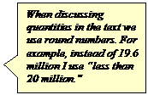  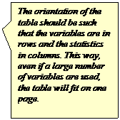
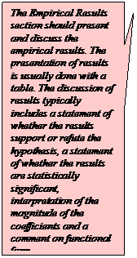  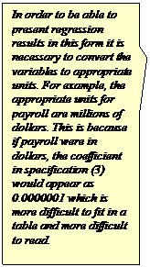  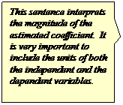 | 3. Empirical Results  I estimate three different specifications. The dependent variable in each specification is performance, as measured by the percentage of games won. Pay inequality and total payroll are the independent variables. Table 2 shows the results. In the first specification, I regress performance on the share earned by the top 20% of players. The coefficient on the share of top 20% is negative and statistically significant. This indicates that teams with higher pay inequality tend to win fewer games. A one percentage point increase in the share of payroll earned by the top 20% of players is associated with about half of a percentage point decline in the percentage of games won.  Table 2: Regression Results  Dependent variable: winning percentage (in %)  (1) (2) (3)  Intercept 77.3 (7.43)** 59.9 (9.51)** 37.35 (15.37)*  Top20share (in %) -0.45 (0.12)** -0.27 (0.13)* -0.28 (0.13)*  Payroll (in mil. USD) 0.10 (0.04)**  Log of Payroll 7.09 (2.43)**  R-squared 0.19 0.29 0.29  Adjusted R-squared 0.18 0.26 0.27  Number of observations is 60.  Standard errors are in parentheses.  ** significant at 1%, * significant at 5%  In the second specification I include total payroll as an independent variable. Payroll is a measure of the financial resources which can affect performance - the higher the payroll, the higher the quality of players and, generally, the better the performance. Therefore, including payroll may increase the precision of the estimated coefficient on pay inequality. More importantly, it is possible that pay inequality is correlated with total payroll. If low payroll teams tend to have more pay inequality, then the coefficient on pay inequality in specification (1) is biased. Indeed, the correlation coefficient between the share earned by the top 20% of players and total payroll is -0.5. Teams with high pay inequality may perform worse not because of pay inequality, but because they are also the teams with a lower payroll. Therefore, in order to measure the effect of pay inequality on performance, I need to control for total payroll.  Once I control for total payroll, the coefficient on the share of the top 20% remains statistically significant but the magnitude drops substantially. Holding payroll constant, a one percentage point increase in the share earned by the highest paid 20% is associated with a 0.27 percentage point decline in the percentage of games won. The impact of inequality on performance does not seem enormous. For example, a five percentage point increase in inequality for the team with median inequality would shift the team up 13 spots in the inequality ranking, but its performance ranking would drop by only 2 spots. The coefficient on total payroll is positive and statistically significant. A one million dollar increase in total payroll is associated with about 0.1 percentage point increase in the percentage of games won. This indicates that greater financial resources tend to improve performance. Adding payroll as an independent variable led to an increase in R-squared from about 0.19 to 0.29.  Finally, in specification (3) I include the logarithm of payroll instead of payroll. I want to verify that the result in specification (2) is robust to different functional forms. In addition, the effect of an additional one million dollars may be smaller for a team with a 100 million payroll than for one with a 20 million payroll. Thus, including payroll in logarithm seems appropriate. The coefficient on the share of the top 20% remains statistically significant with roughly the same magnitude. The log of payroll is statistically significant. A one percent increase in payroll is associated with about 0.07 percentage points increase in the percentage of games won. | 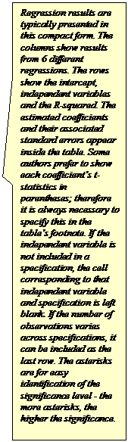  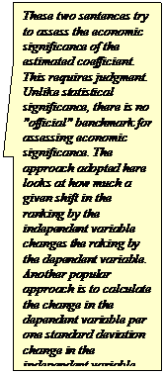
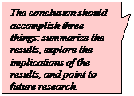  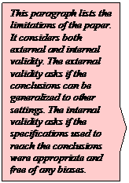  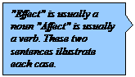 | 4. Conclusion  The analysis in this paper shows that pay inequality within MLB teams has a negative effect on performance. The effect remains statistically significant even after controlling for total payroll. The result is the same as that of DeBrock et al. (2004) who use data from 1985 through 1998. My paper confirms their finding using the most recent data and using a different measure of pay inequality.  The fact that pay inequality leads to worse performance implies that managers should strive for pay equality in their teams. For example, instead of hiring two low-priced players and one superstar, performance may be better if three medium-priced players are hired. Given these results, it is surprising that there is not a more equal distribution of pay in baseball. One possible explanation is that managers may care about attendance as well as winning. They may be willing to sign up an expensive superstar who will attract fans even though it will increase pay inequality and may hinder performance.  The conclusions above are subject to a number of limitations. First, it is unclear to what extent the results can be generalized to other sports. Each sport requires a different degree of cooperation among team members. Therefore, the relationship between pay inequality and performance is likely to differ across sports. Second, the error terms for each team could be correlated over time. For example, if a team wins a lot of games one year given its payroll and pay inequality, that team is likely to win a lot of games the next year as well. Therefore, the estimation procedure may need to correct for this autocorrelation. Finally, there may be other variables that affect performance, e.g. coach salary or quality of training facilities. Including these in the regression would increase the precision of my estimates as well as eliminate potential omitted variable bias.  The channels through which pay inequality affects performance are not clear. I can think of two possibilities. One is that pay inequality leads to tensions within the team and impairs performance. The other possibility is that baseball requires players of similar quality. Pay inequality is probably associated with skill inequality, and it may be the skill inequality that drives down performance. An excellent pitcher cannot win the game when the outfielders cannot catch or throw. It may be possible to distinguish these two channels empirically. Using statistics on individual player skill level, one could construct a measure of skill inequality for a team and include it as an additional control. The coefficient on pay inequality in that case would capture the effect of pay inequality on performance while holding skill inequality constant. A negative impact of pay inequality would then support the idea that pay inequality leads to tensions which affect performance. This investigation, however, is left for future research. | 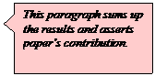    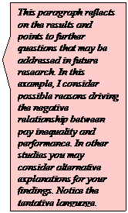
 | References:  DeBrock, Lawrence, Wallace Hendricks, and Roger Koenker. 2004. Pay and performance: The impact of salary distribution on firm-level outcomes in baseball. Journal of Sports Economics 5 (August): 243–261.  Frick, Bernd, Joachim Prinz, and Karina Winkelmann. 2003. Pay inequalities and team performance: Empirical evidence from the North American major leagues. International Journal of Manpower 24: 472-491.
 | Appendix:  Data with documentation and results:MLB.xls
 | (back to the top)
* I would like to thank Mary Mar, Youghwan Song, Stephen Schmidt and two anonymous referees for their helpful comments. I am also grateful to many Union College students for their useful feedback.

